Access control and parking double verification operation manual

1. Add Device

Enter：Parking/Basic parking management/Device/New, Add a device;

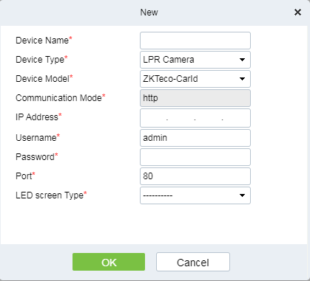

The test device for the following steps is Carid.

1. Add Parking Area，import and export area,Guard Booth,channel and other operations；
2. Add double Verification Channel;

Enter: Parking/Basic parking management/Double Verification Channel/New, The door equipped with access control equipment is bound to the guard booth.After binding, a variety of combined dual verification can be realized according to the type of access control equipment and parking equipment:

1. face (card, fingerprint, QR code, depending on the type of access control device) + license plate LPR dual recognition
2. face (card, fingerprint, QR code, depending on the type of access control device) + UHF label dual identification

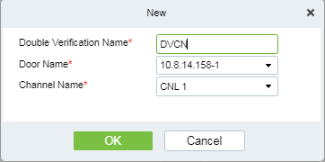

The door of the access control equipment can not be selected repeatedly. When the access control equipment is directly filtered, one door corresponds to one channel;

1. Double verification parameter settings，the setup result are shown in the figure below,After opening, the waiting time for double verification should be set, supporting 10~300s waiting time, and the default is 10s;

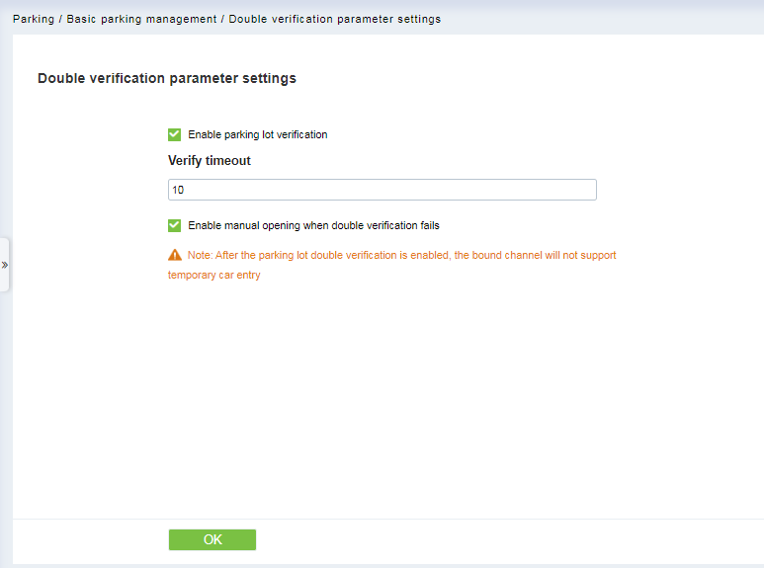

1. License plate information of the registration personnel;

Enter: Parking/Vehicle Management/License Plate Registration/New,select the appropriate person and add the appropriate license plate,click ok after a successful setting;

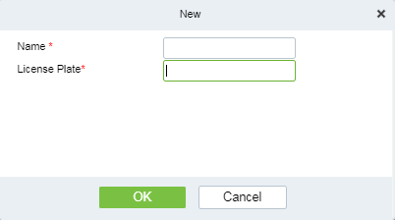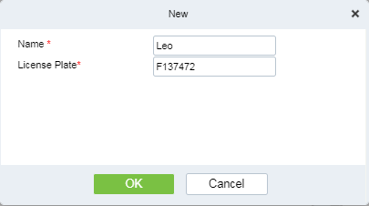

1. Perform vehicle authorization；

Enter: Parking/Vehicle Management/Vehicle Authorization/Fixed Vehicle batch authorization,the relevant setting information is as follows，click confirm after a successful setting;

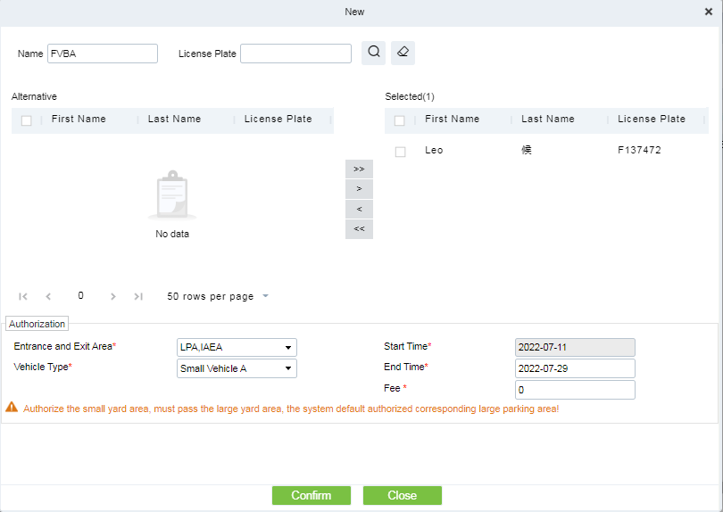

1. Guard booth Monitoring

If only the license plate recognition is conducted and no personnel information verification is carried out, the double verification timeout will be displayed after a certain time；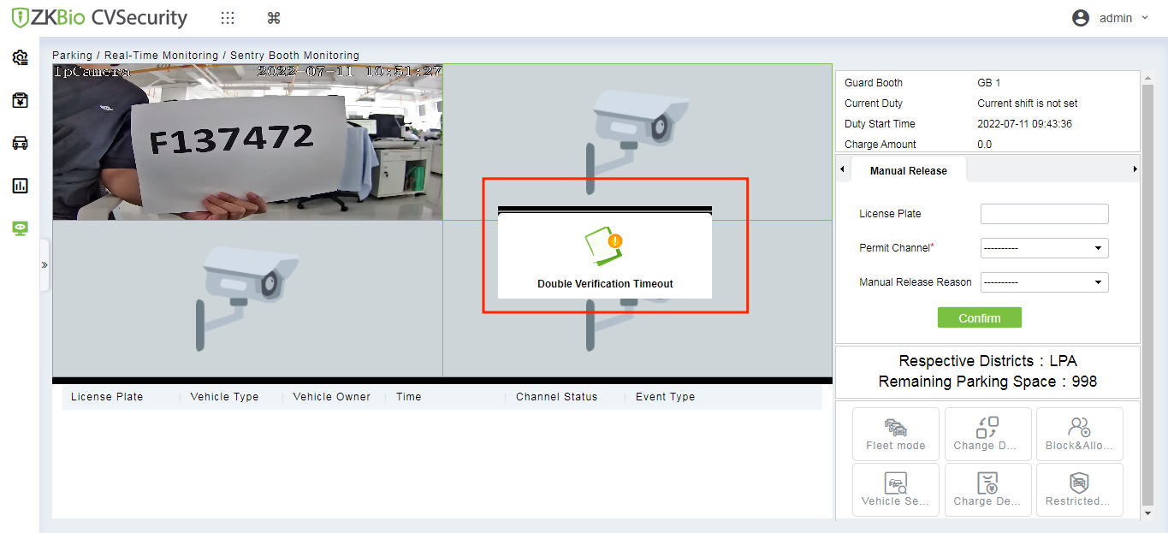

1. After the verification of the personnel information (fingerprint, face, swipe card),license plate recognition information will be displayed on the guard booth monitoring page;

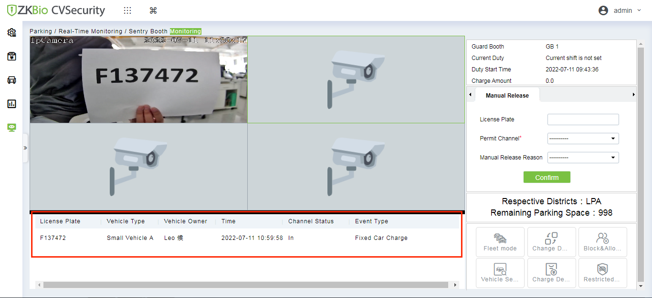

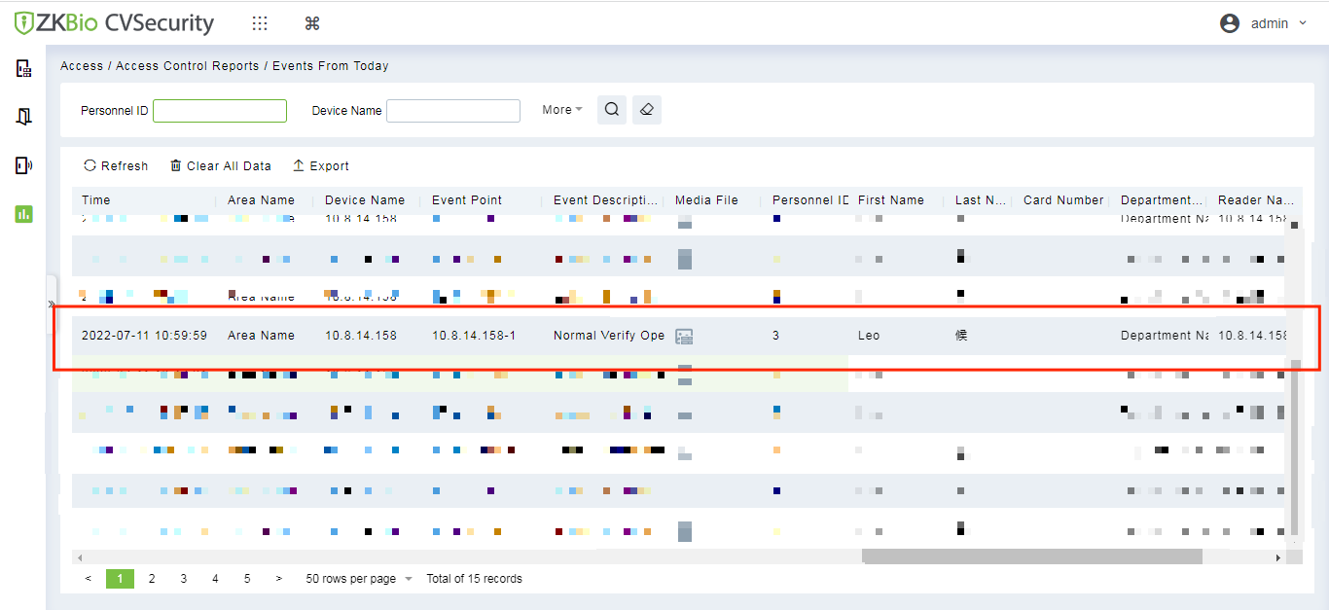

1. If the double verification fails, the page will bounce to remind the gate, then you can choose whether to open the gate release;

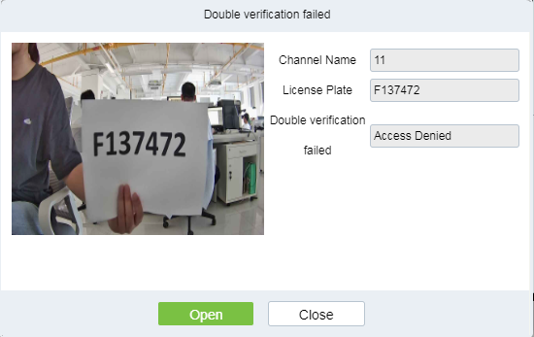

Double verification failure can include: personnel unauthorized, personnel unregistered, illegal time period, people have expired, prohibited list, and failure of integrated verification